**COC 4 MAINTAIN AND REPAIR COMPUTER SYSTEM AND NETWORKS**

• **Creating back up files using acronis**

1. Install acronis true image 2015
2. Click yes
3. Click add backup
4. Click create new backup
5. Click yes
6. Click source
7. Click files and folders
8. Click grades
9. Click ok
10. Click select destination
11. Click browse
12. Click computer local disk d
13. Click ok
14. Click back up now
15. Then wait until it finish

**COC 1**

1. Assemble and disassemble system unit & parts of mother board
2. Create bootable flash drive
3. Installation of windows 8
4. Installation of Microsoft office, google, VLC, adobe, anti- virus

**COC 2**

1. Straight Connection: 8pcs
2. Configured router
3. Sharing internet
4. Configured access point
5. Firewall

**COC 3**

1. Install and configure DHCP
2. Install and configure File Server
3. Install and configure Remote Desktop
4. Install and configure DNS
5. Install and configure Print Document

**COC 4**

1. Install & Create Back up files

**SAFETY PROCEDURE** is a common task. It is a general knowledge in our workplace. In most cases, one must be trained to apply safety procedures in particular place or in an environment of a certain work, such as factory where there is heavy machineries, electronics and high voltage facilities.

**SAFETY PROCEDURES** may be able to promote a great stability of

accompany, to ensure safety of their own products, their facilities and most especially their personnel during and after work responsibility. Therefore, it is our goal and responsibility as a worker, in any field of our skills and even in our great profession, to have these skill and knowledge for future application in our workplace.

**5S OF GOOD HOUSE KEEPING**

* S- **sieri** /Sort

o Take out unnecessary items and dispose

* S- **seiton** /Systematize o Arrange necessary items in good order for use
* S- **seiso/** Sweep o Clean your workplace
* S- **seiketsu/** Sanitize o Maintain high standard of housekeeping
* S- **Shitsuke/** Self- discipline o Do things spontaneously without being told

**GENERAL SAFETY PRECAUTIONS**

1. Remove power from the circuit or equipment before working on it.
2. Remove and replace fuses only after the power to the circuit has been de energized.
3. Make sure all equipment is properly grounded.
4. Use extreme caution when removing or installing batteries containing acid.
5. Use cleaning fluids only in well- ventilated spaces.
6. Dispose of cleaning rags and other flammable materials in tightly closed metal containers.
7. In case of an electrical fire, de energize the circuit and report it immediately to the appropriate authority.

**HIGH VOLTAGE SAFETY PRECAUTIONS**

1. Consider the result of each act.
2. Keep away from live circuits.
3. Do not work alone.
4. Do not tamper with interlocks.
5. Do not ground yourself.
6. Never energize equipment in the presence of water leakage.

**PERSONAL SAFETY PRECAUTIONS**

1. Work only in clean dry areas.
2. Do not wear loose or flapping clothing.
3. Wear only nonconductive shoes.
4. Remove all rings, wristwatches, bracelets, ID chains and tags, and similar metal items.
5. Do not use bare hands to remove hot parts.
6. Use a shorting stick to remove high voltage charges on capacitors.
7. Make certain that the equipment being used is properly grounded.
8. Remove power to a circuit prior to connecting alligator clips.
9. When measuring voltages over 300 volts, do not hold the test probes.

General Safety Safe working conditions help prevent injury to people and damage to computer equipment. A safe workspace is clean, organized, and properly lighted. Everyone must understand and follow safety procedures.

Follow the basic safety guidelines to prevent cuts, burns, electrical shock, and damage to eyesight. As a best practice, make sure that a fire extinguisher and first-aid kit are available in case of fire or injury. Poorly placed or unsecured cables can cause tripping hazards in a network installation. Cables should be installed in conduit or cable trays to prevent hazards.

There are certain procedures you should follow when you are installing items in your system. Below is information to avoid damage to your system or/and yourself.

* Before entering the computer, move computer off the carpet (for static purposes). If you’re not able to then try not to move on the carpet to keep the static from building.
* Disconnect all cables including power cord. I can't stress this enough. Remove the power cord, monitor, keyboard, mouse, phone line, network cable, speakers, printer, scanner, USB cables, cable modem, DSL modem and anything else that is connected. (it should look similar to the picture below)
* With everything disconnected, push the power button for 5 seconds. (with power cord disconnected). The computer can store power even with the power cord disconnected. Pushing the power button drains that power (only if the power cord is disconnected). **VERY IMPORTANT!!!**
* Touch something metal on the case of the system to release any static build up in your body.
* Computers are the best dust collectors. **Do not blow on the dust with your breath**. Your breath has moisture and electronics hate moisture.
* If you want to clean the inside of the system of dust, use compressed air that is designed for electronics.
* While using the compressed air, do not hold down the button. Not only will they can get cold, moisture will also form. Use quick short bursts.
* When handling parts, do not touch the bronze teeth. Hold the parts on the edges if at all possible.
* If you are troubleshooting noise issue, some people will stick a pencil or other objects in the fan to stop the fan from turning to see if the noise goes away. DON'T DO THAT! The fan might shatter the pencil, cause a fire, cause electrical shock or short.
* If you disconnect the cable that goes to the processor fan to check for noise, do not leave system on for long with it disconnected.
* Be careful while inside system, the system has sharp edges.
* Never put your hands inside system when the system is either plugged in or turned on.
* Some computer desks have a compartment that you can put your computer in. Make sure that compartment is well ventilated. If it is not ventilated, it can fry the system. If it is not well ventilated, you can drill holes in the desk to give it ventilation, or you can install a small fan in the desk that will circulate air.
* Do not connect or disconnect cables while the system or device is turned on. (unless it is USB. USB can be disconnected or connected while system is on). Equipment can be damaged by this.

**\*\*\*\*VERY VERY IMPORTANT NOTE\*\*\*\***

If you have access to your personal files, make sure they are backed up before tinkering with the system. Sometimes there can be more than one issue and one of the issues may not show till you start tinkering with the system. For example, I have seen a hard drive be bad but it works as long as the system is on. However when you turn the system off, the hard drive doesn't work anymore. Once that happens, you can't get access to your files.

Electrical Safety Follow electrical safety guidelines to prevent electrical fires, injuries, and fatalities in the home and the workplace. Power supplies and CRT monitors contain high voltage.

**CAUTION**

Do not wear the antistatic wrist strap when repairing power supplies or CRT monitors. Only experienced technicians should attempt to repair power supplies and CRT monitors.

Some printer parts become hot during use, and other parts might contain high voltage. Check the printer manual for the location of high-voltage components. Some components retain a high voltage even after the printer is turned off. Make sure that the printer has had time to cool before making the repair.

Electrical devices have certain power requirements. For example, AC adapters are manufactured for specific laptops. Exchanging power cords with a different type of laptop or device may cause damage to both the AC adapter and the laptop.

Procedures to Protect Equipment and Data Replacing equipment and recovering data is expensive and time consuming. This section identifies potential threats to systems and describes procedures to help prevent loss and damage.

ESD and EMI ***Electrostatic discharge*** (ESD), harsh climates, and poorquality sources of electricity can cause damage to computer equipment. Follow proper handling guidelines, be aware of environmental issues, and use equipment that stabilizes power to prevent equipment damage and data loss.

**Static electricity** is the buildup of an electric charge resting on a surface. *Electrostatic discharge (ESD)* occurs when this buildup jumps to a component and causes damage. ESD can be destructive to the electronics in a computer system.

At least 3000 volts of static electricity must build up before a person can feel ESD. For example, static electricity can build up on you as you walk across a carpeted floor. When you touch another person, you both receive a shock. If the discharge causes pain or makes a noise, the charge was probably above 10,000 volts. By comparison, less than 30 volts of static electricity can damage a computer component.

**ESD** can cause permanent damage to electrical components. Follow these recommendations to help prevent ESD damage:

* Keep all components in antistatic bags until you are ready to install them.
* Use grounded mats on workbenches.
* Use grounded floor mats in work areas.
* Use *antistatic wrist straps* when working on computers.

*Electromagnetic interference (EMI)* is the intrusion of outside electromagnetic signals in a transmission media, such as copper cabling. In a network environment, EMI distorts the signals so that the receiving devices have difficulty interpreting them.

**EMI** does not always come from expected sources, such as cellular phones. Other types of electric equipment can emit a silent, invisible electromagnetic field that can extend for more than a mile (1.6 km).

There are many sources of EMI:

* Any source designed to generate electromagnetic energy
* Man-made sources like power lines or motors
* Natural events such as electrical storms, or solar and interstellar radiations

**Wireless networks** are affected by *radio frequency interference (RFI)*. **RFI** is caused by radio transmitters and other devices transmitting in the same frequency. For example, a cordless telephone can cause problems with a wireless network when both devices use the same frequency. Microwaves can also cause interference when positioned in close proximity to wireless networking devices.

Climate affects computer equipment in a variety of ways:

* If the environment temperature is too high, equipment can overheat.
* If the humidity level is too low, the chance of ESD increases.
* If the humidity level is too high, equipment can suffer from moisture damage.

Power Fluctuation Types **Voltage** is the force that moves electrons through a circuit. The movement of electrons is called *current*. Computer circuits need voltage and current to operate electronic components. When the voltage in a computer is not accurate or steady, computer components might not operate correctly. Unsteady voltages are called *power fluctuations*.

The following types of AC power fluctuations can cause data loss or hardware failure:

* ***Blackout*:** Complete loss of AC power. A blown fuse, damaged transformer, or downed power line can cause a blackout.
* ***Brownout*:** Reduced voltage level of AC power that lasts for a period of time. Brownouts occur when the power line voltage drops below 80 percent of the normal voltage level. Overloading electrical circuits can cause a brownout.
* ***Noise*:** Interference from generators and lightning. Noise results in poor quality power, which can cause errors in a computer system.
* ***Spike*:** Sudden increase in voltage that lasts for a short period and exceeds 100 percent of the normal voltage on a line. Spikes can be caused by lightning strikes, but can also occur when the electrical system comes back on after a blackout.
* ***Power surge*:** Dramatic increase in voltage above the normal flow of electrical current. A power surge lasts for a few nanoseconds, or onebillionth of a second.

Power Protection Devices To help shield against power fluctuation problems, use *power protection devices* to protect the data and computer equipment:

* ***Surge suppressor*:** Helps protect against damage from surges and spikes. A surge suppressor diverts extra electrical voltage that is on the line to the ground.
* ***Uninterruptible power supply (UPS)*:** Helps protect against potential electrical power problems by supplying a consistent level of electrical power to a computer or other device. The battery is constantly recharging while the UPS is in use. The UPS provides a consistent quality of power when brownouts and blackouts occur. Many UPS devices can communicate directly with the computer operating system. This communication allows the UPS to safely shut down the computer and save data prior to the UPS losing all electrical power.
* ***Standby power supply (SPS)*:** Helps protect against potential electrical power problems by providing a backup battery to supply power when the incoming voltage drops below the normal level. The battery is on standby during normal operation. When the voltage decreases, the battery provides DC power to a power inverter, which converts it to AC power for the computer. This device is not as reliable as a UPS because of the time it takes to switch over to the battery. If the switching device fails, the battery cannot supply power to the computer.

**CAUTION**

UPS manufacturers suggest never plugging in a laser printer to a UPS because the printer could overload the UPS.

**Information Sheet No 1.1-2 Basic terms, concepts, functions and characteristics of PC hardware components**

**Learning objective:**

Upon completion of this module, the students will be able to

1. Identify different parts of the computer.
2. Define computer terms

**Basic Computer Terms**

**Address** – a number that represent a unique location in memory

**ALU** – Arithmetic Logic Unit, part of a microprocessor. It does all arithmetic functions and calculation in the CPU.

**ASCII** – American Standard Code for Information Interchange, code representing the character symbols possible for specific hexadecimal codes.

**BIOS** – Basic Input/Output System, the part of the operating system that controls the input and output functions.

**Bit** – the single smallest unit of data in a computer.

**Board** – a shortened reference to a printed circuit board or the insulated surface on which circuit components are mounted and soldered in place.

**Boot** – a term meaning to load DOS or an operating system.

**Byte** – comprised of 8 bits to form a word

**Character** – the equivalent meaning of byte formed.

**Chip**  – a complete electronic circuit which may contain miniature resisters, transistors, diodes, and related circuitry all integrated into a miniature silicon base and mounted in a common housing.

**Computer** – an electronic device designed to make rapid, accurate computations from data programmed into it.

**Control Unit** – decodes each instruction that enters the computer. It then generates the necessary pulses to carry out the functions specified.

**CP/M** – Control Program for Microprocessors, the first operating system developed for microcomputers.

**CPU** – Central Processing Unit, the heart of a system. It controls all data transfer and devices in a microcomputer system.

**DMA** – Direct Memory Access, data transfer involving large blocks of information directly between the memory and disk drives. DMA is controlled by other processors which speeds up data transfer and unloads the central processors of this function.

**DOS**  – Disk Operating System, a software program used to set certain parameters involving the operation of the computer system. To start it up especially data transfer and the disk drives.

**Hardcopy** – a print out or a visual copy on paper.

**I/O** – short for Input/Output, any operation or device that sends or receives data from or to the CPU.

**IC** – short for Integrated Circuit, building blocks of a computer system or other electronics devices comprising many electronics parts such as transistors, resistors, etc. in a single package.

**Interrupt** – an input signal to the processors that sets the order to initialize all system devices for operation.

**Kilo** – prefix which means 1,000 units

**LSI** – Large Scale Integration, describes the intensity of integration commonly used in microprocessors, comprising many ICs.

**Mainframe computers** – the largest and most expensive computers designed specifically to serve business, industry, and government in applications that require mass storage and fast retrieval.

*Example*: Banks, airlines, and the Internal Revenue Service use mainframe Computers

**Mega** – prefix which means 1,000,000 units

**Memory** – the part of a computer that stores vital information for the computer’s operation.

**Microcomputers** – the smallest and least expensive computers, designed for desktop or portable use by an individual at home, yet versatile enough for applications in business, industry, and government

*Example:* Microcomputers enjoyed early popularity in the home for both educations and playing electronic games, but as microcomputers expand in powers such as multi-tasking and multi-user applications, their use in business and industry increases.

**Microprocessor** – the arithmetic logic unit, registers, and timing and decoding circuitry usually contained in a single integrated circuit that controls computer activities.

**Minicomputers** – medium-sized and medium-priced computers that rival the storage capacity and operating speed of smaller main-frames, and are used in business, industry, and government where they perform mostly dedicated or single-task activities.

*Example:* Food processors, laboratories, and hospitals use minicomputers

**Peripheral** – any device or accessory such as a disk drive, printer, modem, or video display added to a microcomputer to provide increased capacity for handling, storing, or presenting data.

**POR** – Power On Reset, or power on routing, term to describe the sequence of operations of a machine during power up.

**Programs** – contain the instructions that tell the computer what to do. It is a sequential set of instructions to solve a particular problem.

**Prototype** – the first of its kind, the original from which later models are

patterned.

**RAM** – Random Access Memory, data can either be read from or written to (read/write).

**Read**  – to get data from a device.

**Reset** – a short pulse during power up of perform control function in computer, used to initialize all system devices for operation.

**ROM** – Read Only Memory, data can only be read from this type of memory. It cannot be altered and contains the basic operating instruction of the computer.

**Unix** – the operating system used by the IBM PC, having a more powerful command structure and greater expandability than CP/M **Write**  – to put data into a device.

**Computer Acronyms**

* **ACE** **-** Asynchronous Communication Element
* **ACPI -** Advance Configuration and Power Interface
* **ADC** **-** Analog-to-Digital Converter
* **ADO** **-** Active Data Object
* **ADSL -** Asymmetric Digital Subscriber Line (variant of DSL)
* **AGP** **-** Accelerated Graphics Port
* **ALU** **-** Arithmetic Logic Unit
* **AMR** **-** Audio Modem Riser
* **API** **-** Application Programming Interface
* **ASCII -** American Standard Code for Information Interchange
* **ATA -** Advanced Technology Attachment

**BCD -** Binary Coded Decimal

**BEDO RAM -** Burst EDORAM

**BIOS -** Basic Input Output System

**BIU -** Bus Interface Unit

**CGI** **-** Common Gateway Interface **CAD -** Computer – Aided Design **CMOS** **-** Complementary Metal Oxide Semiconductor

**CPU -** Central Processing Unit

**CRT** **-** Cathode Ray Tube

**DMA -** Direct Memory Access

**DTE** **-** Data Terminal Equipment

**DDR** **-** Double Data Rate

* **DIMM -** Dual Inline Memory Module
* **DLL -** Dynamic Link Library
* **DNS -** Domain Name System
* **DOS -** Disk Operating System
* **DRAM** **-** Dynamic Random Access Memory
* **DSL** **-** Digital Subscriber Line
* **DVD** **-** Digital Versatile Disc
* **EDO** **-** Enhanced Data Output
* **EPROM -** Erasable Programmable Read Only Memory
* **FAT -** File Allocation Table
* **FRAM -** Ferro-Magnetic RAM
* **FDD -** Floppy Disk Drive
* **FSB -** Front Side Bus
* **FTP -** File Transfer Protocol
* **GIF -** Graphics Interchange Format
* **GPRS -** General Packet Radio Service
* **GSM -** Global System for Mobile Communication
* **GUI -** Graphical User Interface
* **HDD -** Hard Disk Drive
* **HTML -** Hypertext Markup Language
* **HTTP -** Hypertext Transport Protocol
* **IC -** Integrated Circuit
* **IBM** **-** International Business Machines
* **ICT -** Information and Communication Technology
* **IDE** **-** Integrated Drive Electronics

**I/O -**Input/ Output

**IP -** Internet Protocol

**IRQ -** Interrupt Request

**IT -** Information Technology

**ISA -** Industry Standard Architecture

**JFET -** Junction Field Effect Transistor

**JPEG -** Joint Photographic Experts Group

**LAN** **-** Local Area Networking **LED -** Light Emitting Diode

**LBA -** Logical Block Addressing

**LSB -** Least Significant Bit

**MAN** **-** Metropolitan Area Network

* **MB -** Megabyte
* **MHz -** Megahertz
* **MIDI -** Musical Instrument Digital Interface
* **MPEG -** Motion Pictures Experts Group
* **MODEM -** Modulator Demodulator
* **MPU -** Microprocessor Unit
* **NTFS -** New Technology File System
* **OCR** **-** Optical Character Recognition
* **OS -** Operating System
* **PATA -** Parallel ATA
* **PC -** Personal Computer
* **PCB -** Printed Circuit Board
* **PCI -** Peripheral Component Interconnect
* **PIC** **-** Programmable Interval Controller
* **PPI -** Programmable Peripheral Interface
* **PDF -** Portable Document Format
* **PNG** **-** Portable Network Graphics
* **PnP -** Plug-and-Play
* **PS/2** - Personal System/2
* **RAID** - Redundant Array of Independent Disks
* **RAM** **-** Random Access Memory
* **RMW -** Read/Modify/Write
* **R/W -** Read/Write
* **ROM -** Read Only Memory
* **RGB** **-** Red Greed Blue

**SATA -** Serial ATA

**SCSI -** Small Computer System Interface

**SDRAM -** Synchronous Dynamic RAM

**SRAM** **-** Static RAM

**SVGA -** Super Video Graphics Array

**SMART -** Self-Monitoring, Analysis, and Reporting Technology

**SSRAM -** Synchronous Static RAM

**TCP/IP -** Transmission Control Protocol / Internet Protocol

**URL -** Uniform Resource Locator

**USB** **-** Universal Serial Bus

**VGA -** Video Graphics Array/Adapter

**VIRUS -** Vital Information Resource Under Seize

* **WAN -** Wide Area Network
* **WAP -** Wireless Application Protocol
* **Wi-Fi -** Wireless Fidelity
* **WLAN -** Wireless Local Area Network
* **www -** World Wide Web

As A technician, you should know and be able to identify the components found in a typical personal computer system. The PC is modular by design. It is called a system because it includes all the components required to make a functional computer.

**System unit** – The main computer cabinet, usually referred to as a case, housing the primary components of the system. This includes the main logic board (System board or mother board), processor, memory, disk drives, switching power supply, and the interconnecting wires and cables. The system unit also includes expansion cards to provide audio, video, networking and other functionality. Expansion cards vary from system to system.

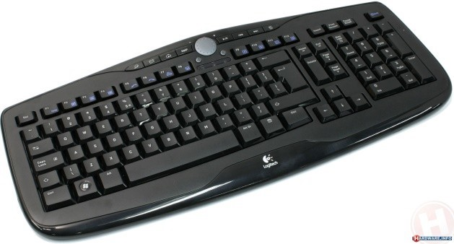**Keyboard** – The most familiar computer input device, the keyboard is used to introduce characters and commands into the system.

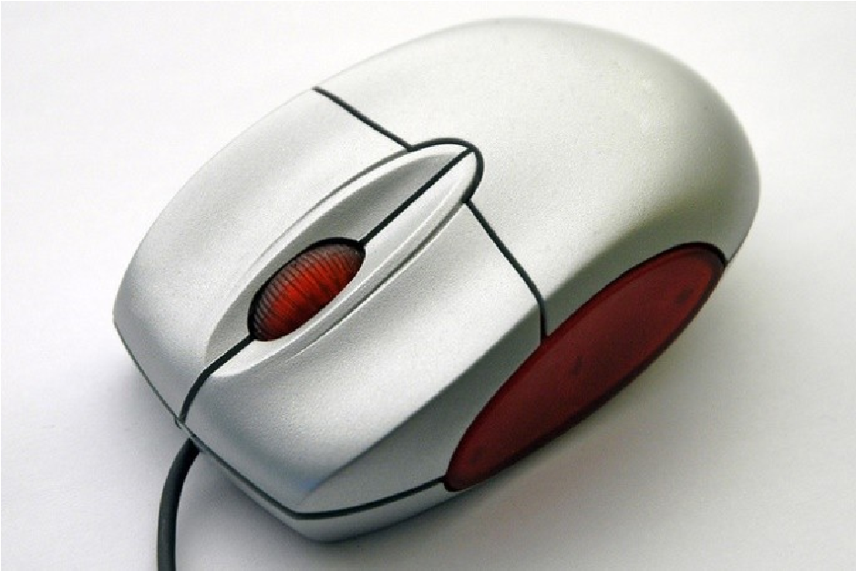**Mouse** – An input device used with graphical user interfaces (GUI) to point to, select, or activate images on the video monitor. By moving the mouse along a surface, the user can cause a cursor on the display to move in a corresponding manner.

**Video display** – A Visual output device that displays characters and graphics on screen.

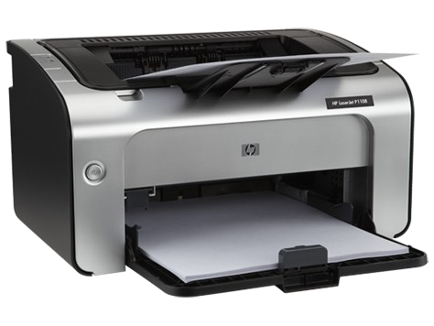 **Printers** – A hard copy output device that applies data to paper. Normally, methods of placing information on a page include dotmatrix printer, inkjet printer and laser printer.

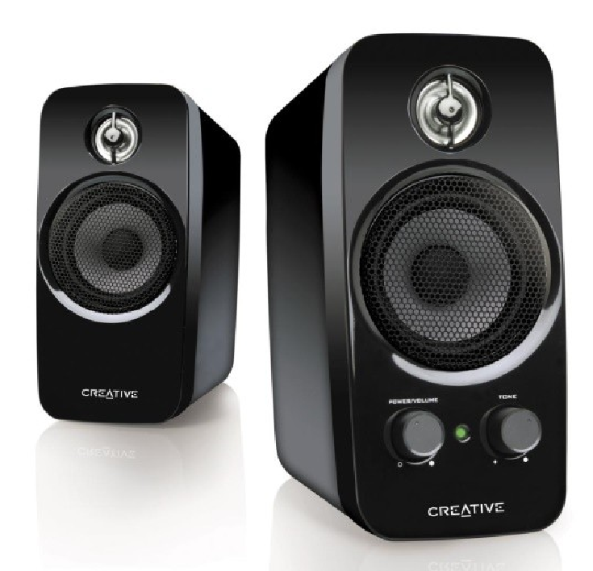**Speakers** –Audio output devices used to deliver voice,music and coded messages.

**System Unit Cases**

The system unit case is typically a metal chassis and removable cover that includes a plastic front panel for aesthetic purposes. The box typically contains the basic parts of the computer system. PCs have been packaged in various case designs. Each design offers characteristics that adapt the system for different environments. Primary characteristics for case design include the following:

* Ventilation characteristics
* Total drive capacity
* Portability
* Mounting methods for the printed Circuit boards
* Footprint(the amount of desk space the case takes up)

With this list of characteristics. PC case designs fall into four basic styles:

1. **Desktops** – PC units that are designed to sit horizontally on a standard desktop behind a keyboard and mouse, usually with the display monitor sitting on the top of the case(hence the name). These cases are typically wider than they are tall.

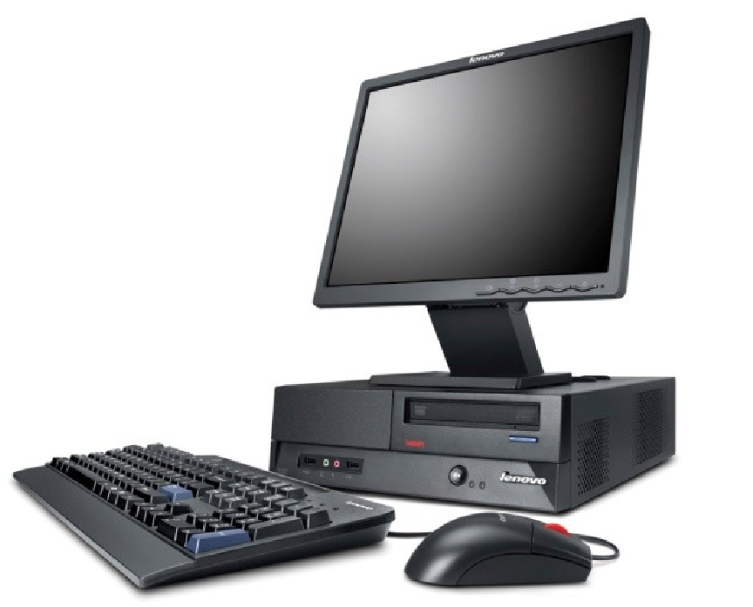

1. **Low-profile desktops** – A special variety of desktop case, referred to as low-profile desktops that reduce the vertical height of the unit by using a short bus extender card, called a backplane that mounts in an expansion slot and permits option adapter cards to be mounted in the unit horizontally.

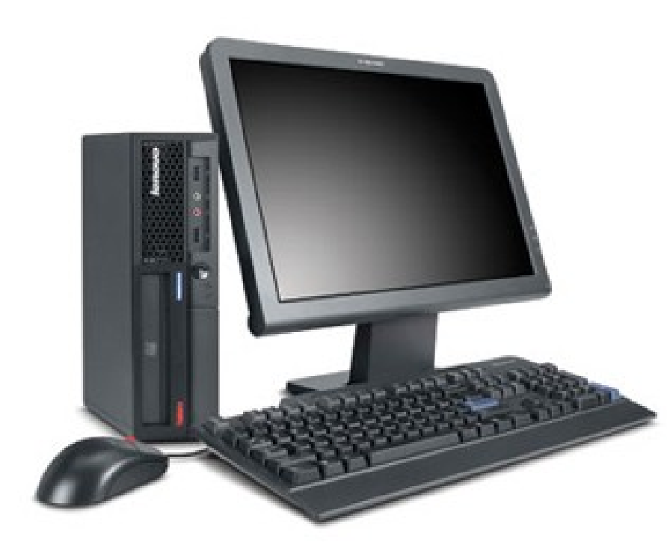

1. **Towers** – Tower cases are designed to sit vertically on the floor beneath a desk to provide more usable workspace on the desktop. Mini towers and mid towers are short towers designed to take up less vertical space. Tower cases also can be placed on a desktop. Internally, their design resembles a vertical desktop unit. They are considerably less expensive than the larger towers because of the smaller amount of materials needed to produce them. Unlike their taller relatives, mini towers do not provide abundant space for internal add-ons or disk drivers.

4.

**Portables**

**(**

**laptops**

**)**

– To free

users from the

desk, an array of

portable PCs have

been

developed

these

units

package

the

system unit, input

units, and output unit into a

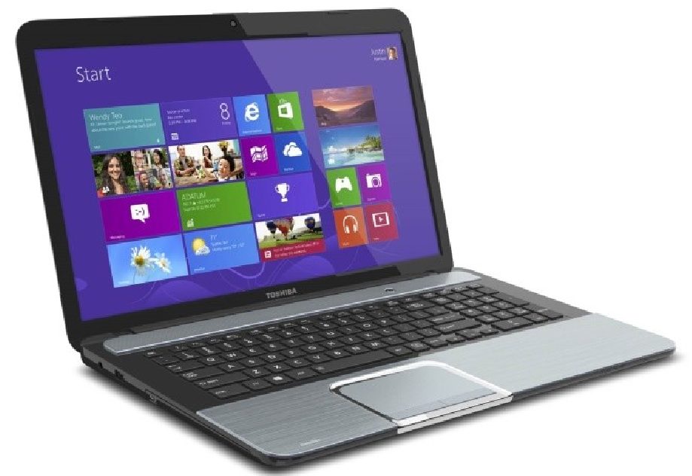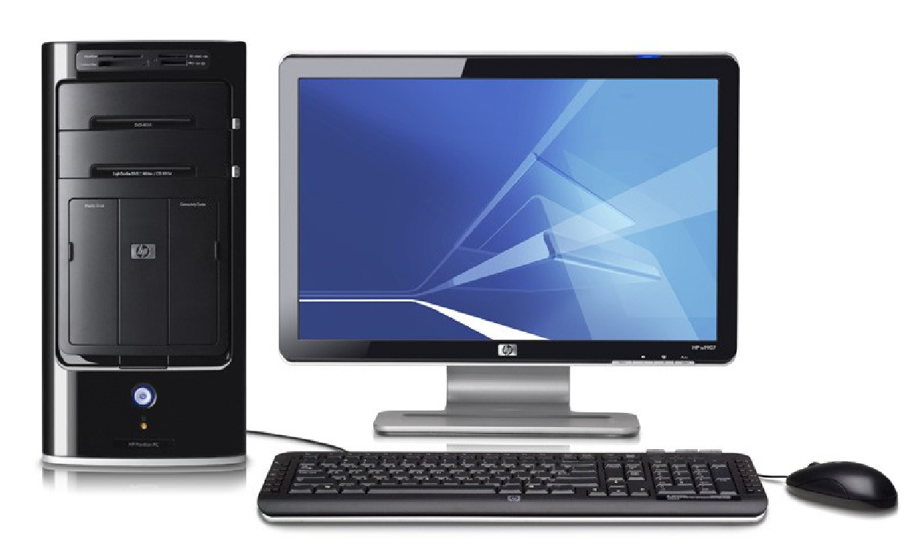

single, lightweight package that can be carried along with the user. The capabilities of modern portable computers make them the equivalent of desktop or tower units in most respects.

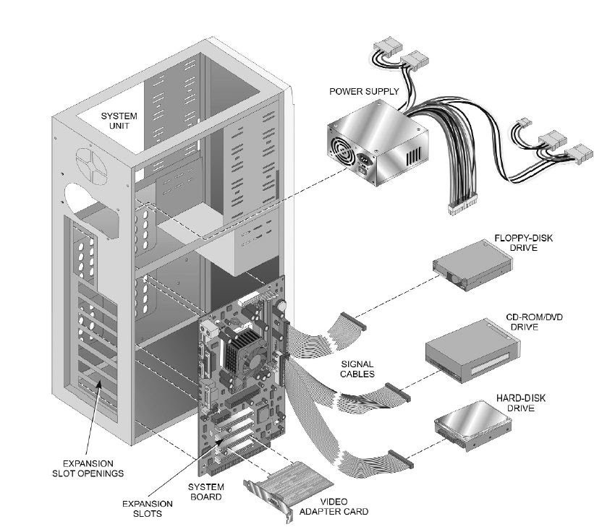

**Inside the system unit**

The system unit is the main portion of the microcomputer system and is the basis of any PC system arrangement. The components inside the system unit can be divided into four distinct subunits: a switching power supply, the disk drivers, the system board, and the option adapter cards.

The major components of interest in a PC system are the following:

* + **Power supply** – The component in the system that converts the AC Voltage from the commercial power outlet to the DC voltage required by the computer circuitry.
  + **System board** – The main component of a personal computer. It contains the major structures that make up a computer system.
  + **Disk drives** – The system’s mass storage devices that hold data for an extended time, even when power is removed from the system. Disk drives include hard disk drives, CD-ROM/DVD drives, floppy disk drives, and tape drives.
  + **Adapter cards** – Interface cards used to enhance the basic system with additional functions. Examples of common adapter cards include video display adapters, modems, and Local Area Network (LAN) cards.
  + **Signal cables** – Connecting cables, typically configured in a flat ribbon format, that pass control signals and data between system components such as disk drives and the system board.

**Form factor**

Form factor is a term used to describe specifications for physical dimensions and electrical compatibility that enables components from different manufactures to work together.

In a PC, from factor is used to describe system board and adapter card sizes, mounting hole patterns for system boards and power supplies, microprocessor placement, and airflow.

These factors determine whether component

❖ (Such as a system board) will fit properly with component  (Such as a system unit case) and connect to component  (Such as a power supply).

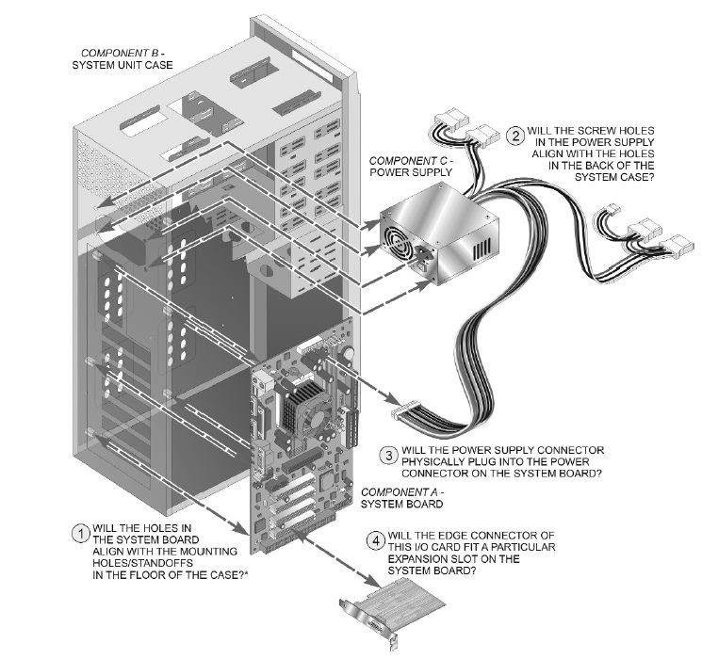

You should be aware of the three major active form factors: ATX, BTX, and NLX.

* 1. **The Advanced Technology Extended (ATX)** form factor was introduced in the mid 1990s as an upgrade to the IBM PC-AT standard that had become the pseudo standard form factor for PCs. It continues to be most widely used form factor currently in use with PC components.
  2. **The Balanced Technology Extended (BTX)** form factor is a newer scalable form factor specification that provides for a wide range of system sizes and profiles. Its main goal is to establish components positions that optimize cooling outside the case to support higher component operating speeds. The BTX form factor design is incompatible with the ATX standard, except that you are able to use ATX power supplies with BTX boards and systems.
  3. **The new low-profile extended (NLX)** form factor, which is the replacement form factor specification form Intel for the Older LPX lowprofile specification. The NLX specification is designed to support newer

PC technologies, such as larger memory modules, advanced microprocessors, and their cooling systems. The NLX system incorporates a backplane that mounts in a slot on the main board and enables adapter cards to be plugged in horizontally. This is one of the major keys to its low profile.

**Information Sheet No. 1.1-3**

**Structure of operating systems**

**Systems in the Computer System**

1. Process Management
2. Main Memory Management
3. File Management
4. I/O System Management
5. Secondary Management
6. Networking
7. Protection System
8. Command-Interpreter System

**PROCESS MANAGEMENT**

A **process** is a **program** in execution: (A program is passive, a process active.) A process has resources (CPU time, files) and attributes that must be managed.

Management of processes includes:

* Process Scheduling (priority, time management, . . . )
* Creation/termination
* Block/Unblock (suspension/resumption )
* Synchronization
* Communication
* Deadlock handling
* Debugging

**MAIN MEMORY MANAGEMENT**

* Allocation/de-allocation for processes, files, I/O.
* Maintenance of several processes at a time
* Keep track of who's using what memory
* Movement of process memory to/from secondary storage.

**FILE MANAGEMENT**

A file is a collection of related information defined by its creator. Commonly, files represent programs (both source and object forms) and data.

The operating system is responsible for the following activities in connections with file management:

* File creation and deletion.
* Directory creation and deletion.
* Support of primitives for manipulating files and directories.
* Mapping files onto secondary storage.
* File backup on stable (nonvolatile) storage media.

**I/O MANAGEMENT**

* Buffer caching system
* Generic device driver code
* Drivers for each device - translate read/write requests into disk position commands.

**SECONDARY STORAGE MANAGEMENT**

* Disks, tapes, optical, ...
* Free space management ( paging/swapping )
* Storage allocation ( what data goes where on disk )
* Disk scheduling

**NETWORKING**

* Communication system between distributed processors.
* Getting information about files/processes/etc. on a remote machine.
* Can use either a message passing or a shared memory model.

**PROTECTION**

* Of files, memory, CPU, etc.
* Means controlling of access
* Depends on the attributes of the file and user

**SYSTEM PROGRAMS**

* Command Interpreters -- Program that accepts control statements (shell, GUI interface, etc.)
* Compilers/linkers
* Communications (ftp, telnet, etc.)

Modifying the Operating System program for a particular machine. The goal is to include all the necessary pieces, but not too many extra ones.

* Typically a System can support many possible devices, but any one installation has only a few of these possibilities.
* **Plug and play** allows for detection of devices and automatic inclusion of the code (drivers) necessary to drive these devices.
* A **sysgen** is usually a link of many OS routines/modules in order to produce an executable containing the code to run the drivers.

**System Calls**

A System Call is the main way a user program interacts with the Operating System.

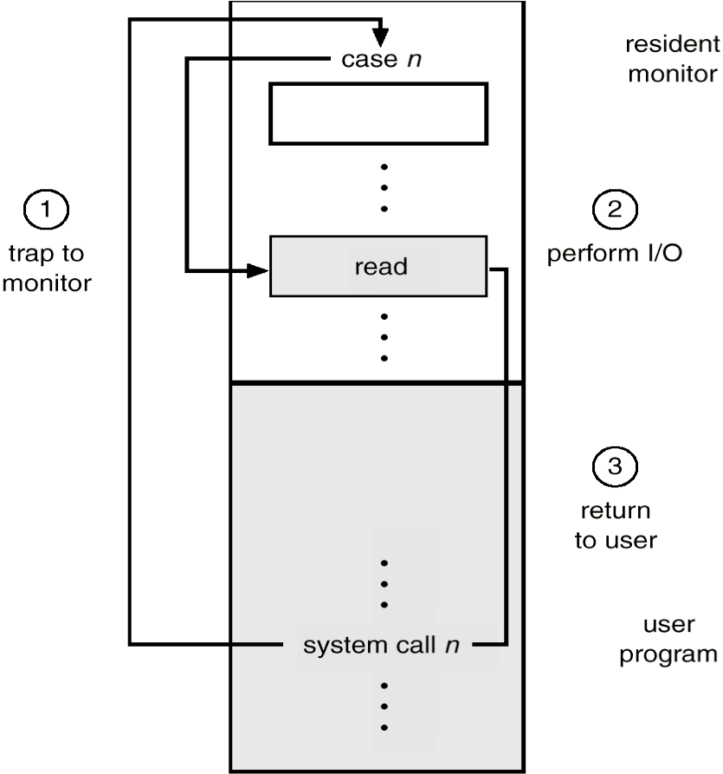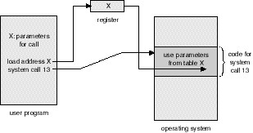

**Two ways of passing data between programs.**

Shared Memory

**These are examples of various system calls.**

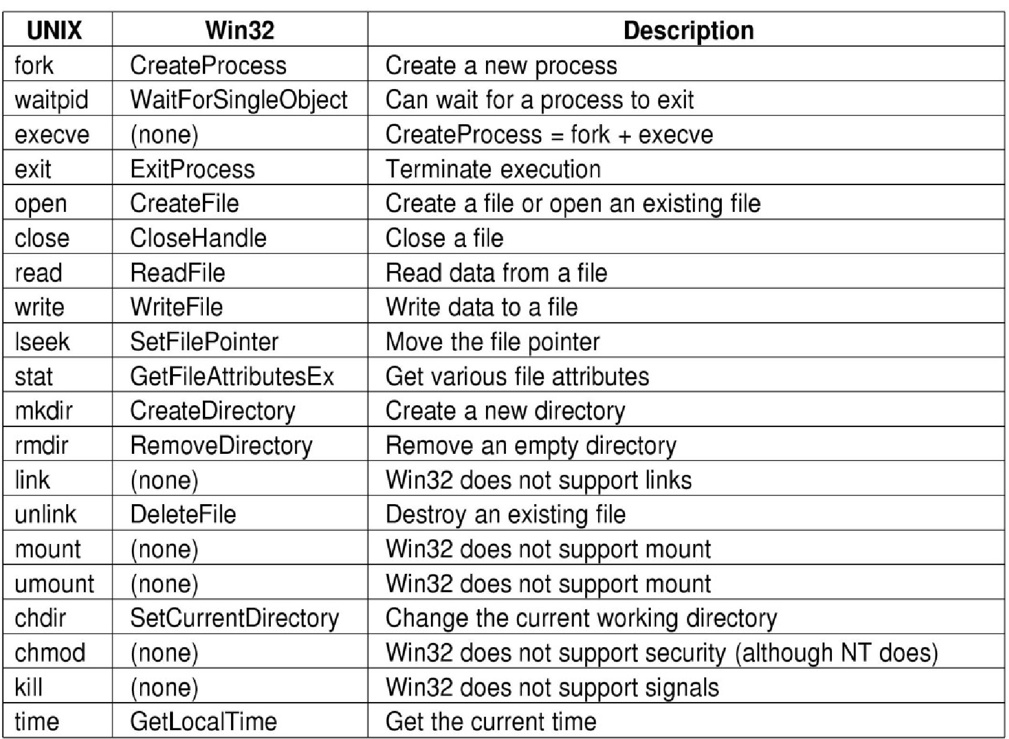

**How An Operating System Is Put Together**

A SIMPLE STRUCTURE:

Example of MS-DOS.

**Application Programming**

**Resident System Programming**

**MS-DOS Drivers**

**ROM - BIOS Device Drivers**

**A LAYERED STRUCTURE:**

**Example of Windows 2000**

|  |  |  |  |  |  |  |  |  |
| --- | --- | --- | --- | --- | --- | --- | --- | --- |
| **System Services** | | | | | | | | |
| **Windows**  **MGR**  **& GDI** |  | **VM**  **Manager** |  | **Process Manager** |  | **Security**  **Referenc**  **Monitor** | **e** | **IO**  **Manager** |
| **Graphics**  **Device**  **Drivers** | **Windows 2000 Kernel** | | | | | | |
| **Hardware Abstraction Layer (HAL)** | | | | | | | | |

**Virtual Machine**

In a Virtual Machine - each process "seems" to execute on its own processor with its own memory, devices, etc.

* The resources of the physical machine are shared. Virtual devices are sliced out of the physical ones. Virtual disks are subsets of physical ones.
* Useful for running different OS simultaneously on the same machine.
* Protection is excellent, but no sharing possible.
* Virtual privileged instructions are trapped.